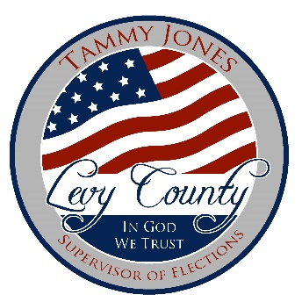

FOR IMMEDIATE RELEASE
May 3, 2021
OFFICE OF

Levy County Supervisor of Elections
421 South Court Street
Bronson, Fl. 32621
www.VoteLevy.gov

Contact: Tammy Jones 352-486-5163
tammy@votelevy.gov
Levy County Announces Audit Plans for Dominion Election Results

New Clear Ballot Partnership will Provide 100% Verifiable, Independent Audit

Levy County, FL – On April 12, 2021, Levy County Supervisor of Elections signed a contract with Clear Ballot Group to audit all future elections. Clear Ballot is the only company with a system capable of tabulating other companies’ ballots, providing the only truly independent comparison of results for purposes of post-election audits. The ClearAudit system also offers 100% verification, so that election officials have full access to review ballots and confirm that tabulation was accurate.

“We are thrilled about our new partnership with Clear Ballot, whose audit system is used and very highly regarded by other counties across Florida,” said Tammy Jones, Levy County Supervisor of Elections. “ClearAudit is completely independent of our Dominion tabulation system, which will provide an important layer of confidence to our results. This system provides our voters with full confidence that election results are accurate.”

“We are looking forward to serving Levy County voters with our state-of-the-art audit solution,” said Clear Ballot CEO Bob Hoyt. “We created ClearAudit using the most advanced digital imaging in the industry and the best technology available so that voters can have full confidence their votes were counted as voters intended them to be.”

Clear Ballot’s commitment to ease of use and modern technology means that its browser-based software runs on the most modern operating systems in the industry and will always be up to date. Their audit solution also adapts to perform different types of audits, to meet the needs of jurisdictions with different state requirements. ClearAudit is currently used in Maryland, Vermont, New York, and the following counties in Florida, which represent nearly a third of all registered voters: Baker, Bay, Broward, Columbia, Hillsborough, Indian River, Leon, Levy, Nassau, Palm Beach, Pinellas, Putnam, St. Lucie, Suwannee.

About Clear Ballot
As the leader in election innovation, Clear Ballot has introduced a new class of tools and a modern approach to voting, enabling unprecedented speed, accuracy, and transparency that officials and the voting public have sought for decades. Clear Ballot entered the election industry with its first product in 2012, disrupting the industry with the nation’s first independent, automated audit, and four years later developed a complete voting system which is now the fastest growing voting system in the industry.

###

