Levy County Commissioner and

School Board Districts
Adopted 2021
STATE HWY 345
Fanning Springs

Chiefland

US HWY 27 ALT

2

Bronson 1

5

Williston
Otter Creek

4
347

3
SE CO RD 337

Cedar Key

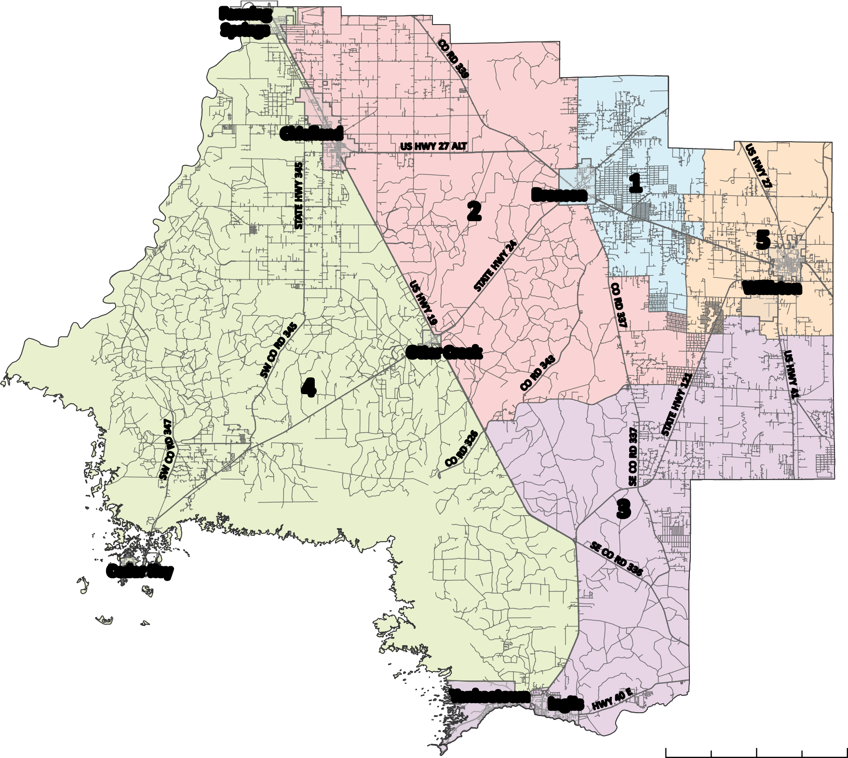
District 1
District 2
District 3
District 4
District 5

Yankeetown Inglis

0 2.5

5 10 Miles

